Disclaimer
This manual is intended for use exclusively with the integration of the Forcepoint system.
It must be implemented only by a qualified Forcepoint system integrator.

Introduction
To integrate SpecterX into Forcepoint, you’ll need to define Mail Routing for filters with a customer SpecterX header, passing email by SMTP to the SpecterX Mail Protection Server, and receiving it back after attachments have been protected and the customer headers removed.

This manual doesn’t use the Forcepoint DLP module, but rather the Forcepoint Mail module, to avoid collisions with any other service that might be configured as a “Third party encryption option”.

There are 3 main things to configure:
- Allow communication between Forcepoint and SpecterX Mail Protection Server
- Define mail routing to the SpecterX Mail Protection Server
- Create a rule to pass emails to the SpecterX Mail Protection Server

This manual will walk you through these steps.

Allow communication between
Forcepoint and SpecterX Mail Protection Server
- Click on ‘Inbound/Outbound’ from the right-side menu and select ‘IP Groups’
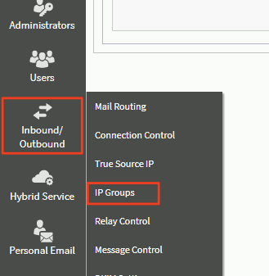
- Under ‘IP Address Group List’ click on ‘Trusted IP Addresses’
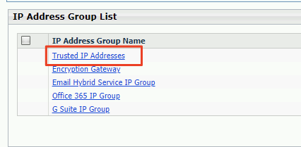
- A screen to ‘Edit IP Group’ will open. Under ‘IP Address Group’, manually add the (1) SpecterX Mail Protection Server IP address, and click the (2) arrow button.
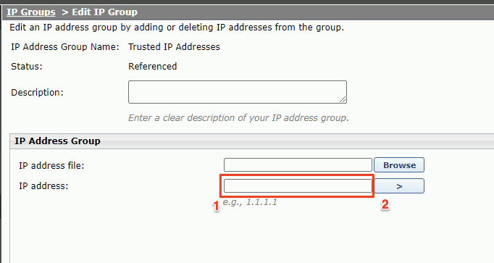
- Now Forcepoint is allowed to communicate with the SpecterX Mail Protection Server.

Define mail routing to the SpecterX Mail Protection Server
- Click on ‘Inbound/Outbound’ from the right-side menu and select ‘Mail routing’
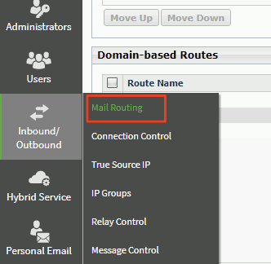
- At the bottom right corner of the ‘Domain-based Routes’ box click ‘Add’
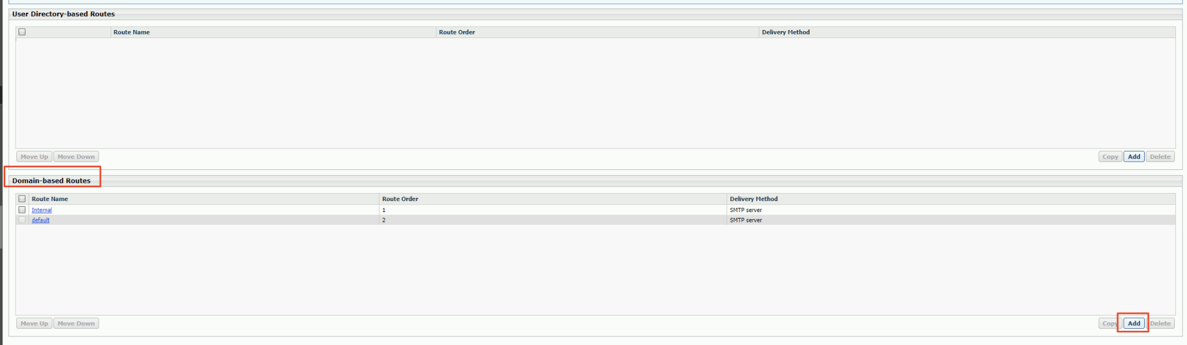
Screen capture zoom-in:

- We will now create a new mail routing rule designed to handle requests going to the SpecterX Mail Protection Server.
- Under ‘Name’, give it the name “SpecterX”
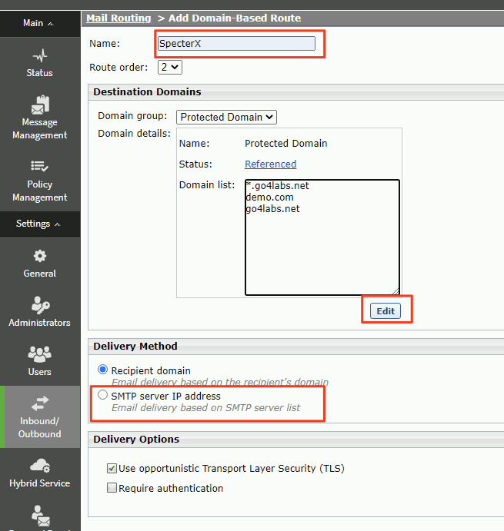
- Under ‘Delivery Method’, set selection to ‘SMTP server IP address’ (instead of ‘Recipient domain’).
After switching to it, a new empty box will appear. Click on the ‘Add’ button.
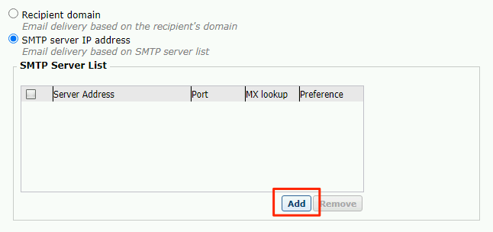
- Under ‘Server address’, add the SpecterX Mail Protection Server IP address.
For ‘Port’ write ‘25’.
Click ‘OK’.
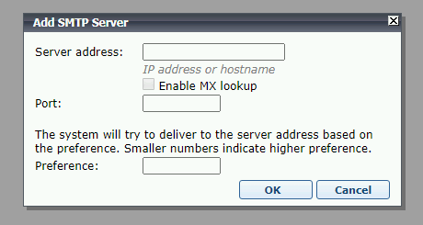
- Keep the ‘Destination Domains’ list empty. Click ‘Edit’, in the new window that will open, (1) select all the addresses under ‘Added Domains’ and (2) click ‘delete’. When the list is empty, click (3) ‘OK’ at the bottom right.
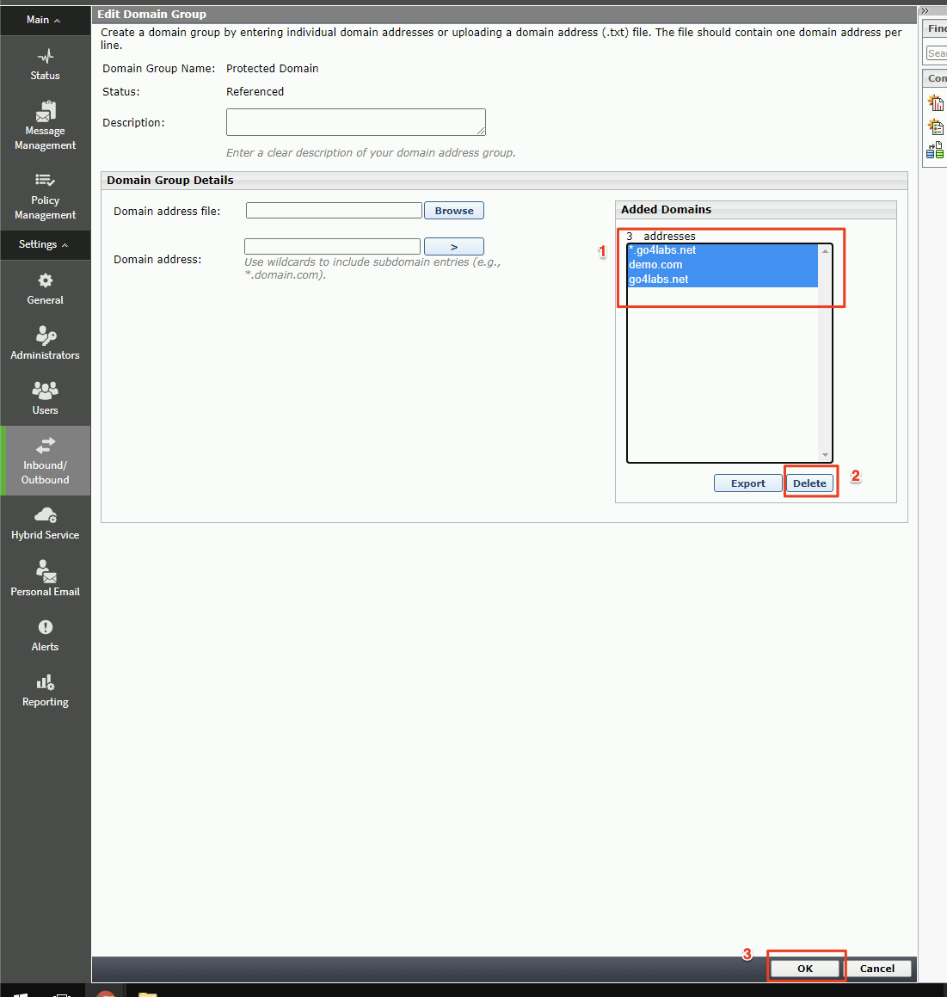
- The final result should look something like this:
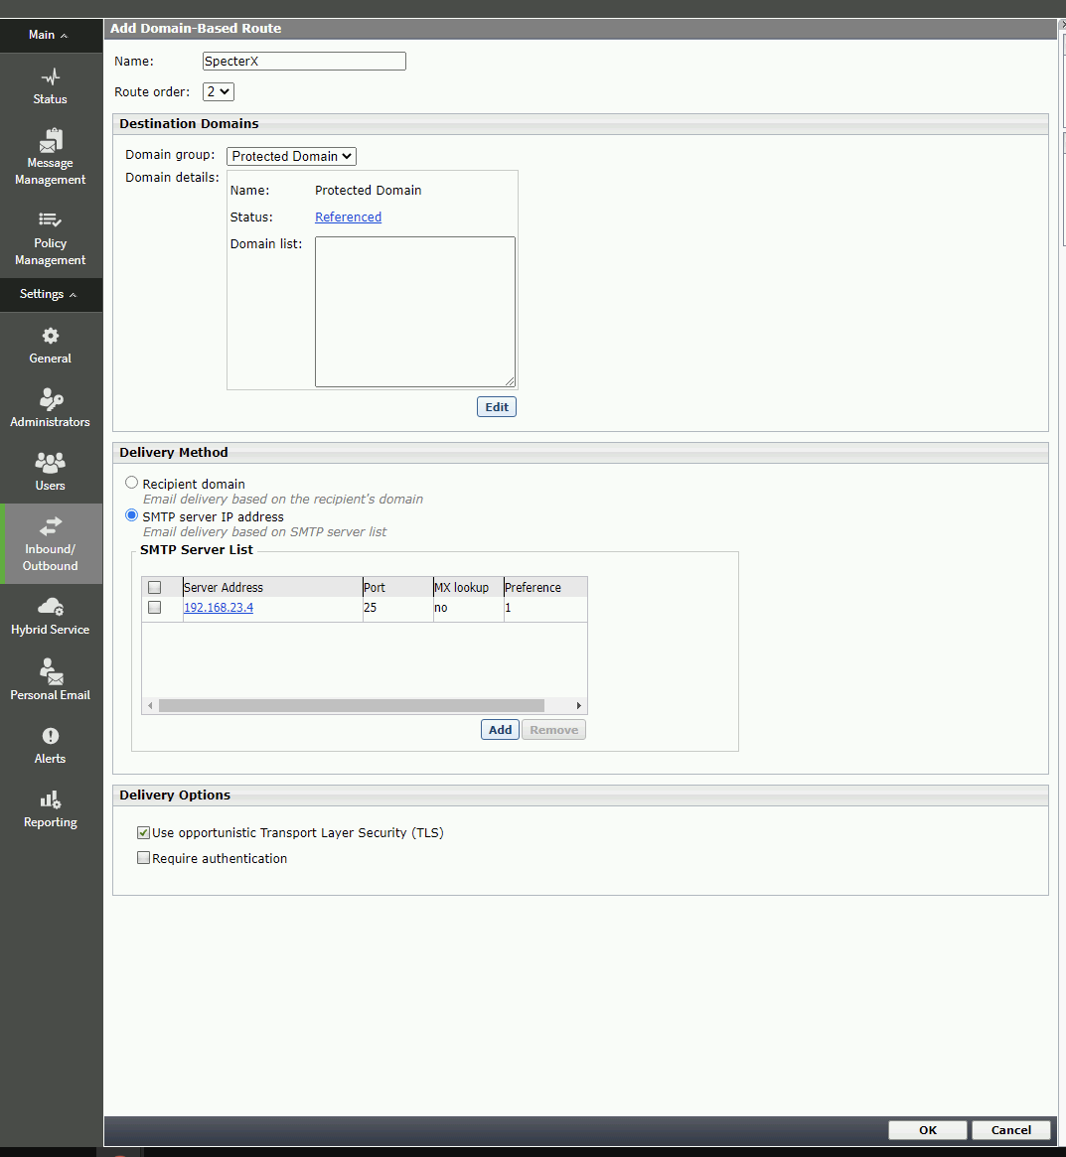
- Now we have a mail routing route ready to pass email to SpecterX Mail Protection Server. On the next step, we will connect this route to a rule.

Create a rule to pass emails
to the SpecterX Mail Protection Server
The following is based on the official Forcepoint manual found here - https://www.websense.com/content/support/library/email/v84/email_help/domain_based_routes_explain_esg.aspx

- Click on ‘Policy Management’ from the right-side menu and select ‘Policies’.
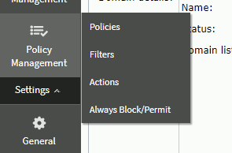
- In the box titled ‘Outbound’ click on ‘Outboard Default’
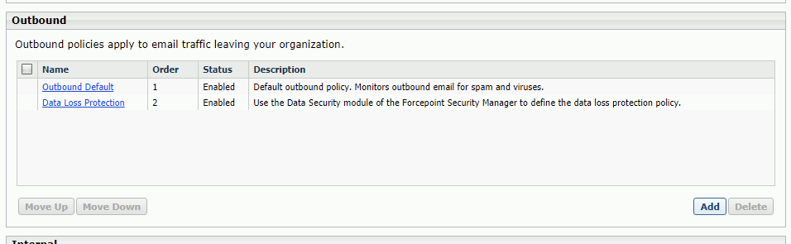
- Add Rule - Add filter based on SpecterX header (see screenshot below):
  - Under ‘Condition’ click ‘Add’ to add a new filter rule
  - Choose ‘Properties’
  - Select ‘Search specific fields’ and choose ‘Other header (may be user-defined)’
  - Type-in header name ‘X-SpecterX-Protection’.
  - Value should be ‘true’
- Click on ‘Policy Management’’ from the right-side menu and select ‘Actions’.
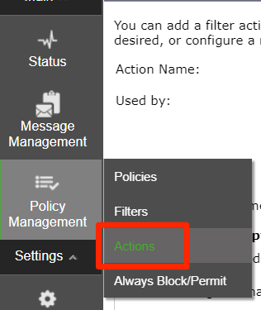
- Define an action to send the email to the SpecterX Mail Protection Service (see screenshot below):
  - Action name: Protect with SpecterX
  - Used by: Data loss prevention
  - Make sure only “Deliver email messages based on domain-based route” is selected.
  - From the dropdown, choose the newly created Mail Routing rule named ‘SpecterX’
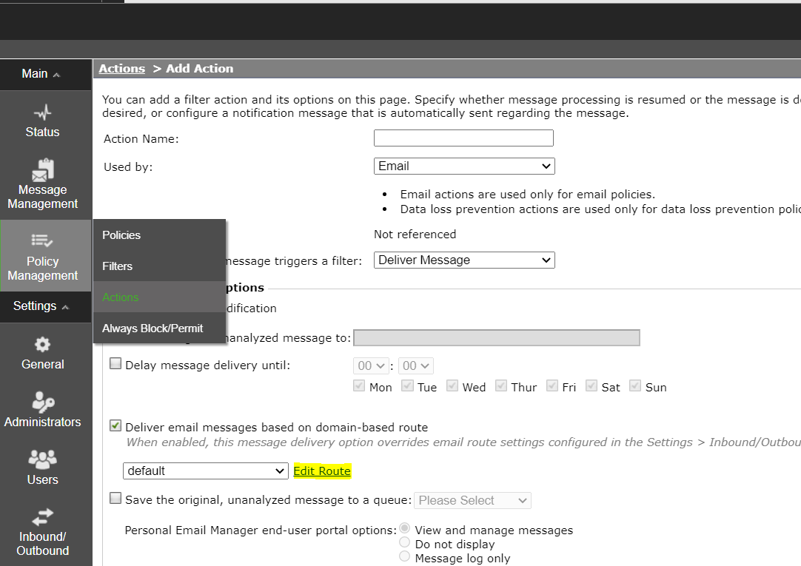
- Switch to the DATA Forcepoint module from the top-left of the screen (DLP configuration)
- Choose ‘Policy Management’ from the left-side menu, and click ‘DLP Policies’ -> ‘Manage Policies’
- Under the ‘Manage DLP Policies’ find the ‘Add’ button.
- Choose ‘Custom Policy’ and define the policy as follows:
- Under “Policy Name” write “SpecterX - Secure Mail”
- Also under “Rule Name” in the section below
- Click ‘Next’ to get to the ‘Condition’ tab
- Click ‘Add’ to create a new condition and define it as follows:
  - Choose the ‘Search specific fields’ option.
  - Select ‘Other header (may be user-defined)’
    - Choose ‘User-defined header’ and insert the following header:
x-specterX-protection: true
  - Deselect all other options
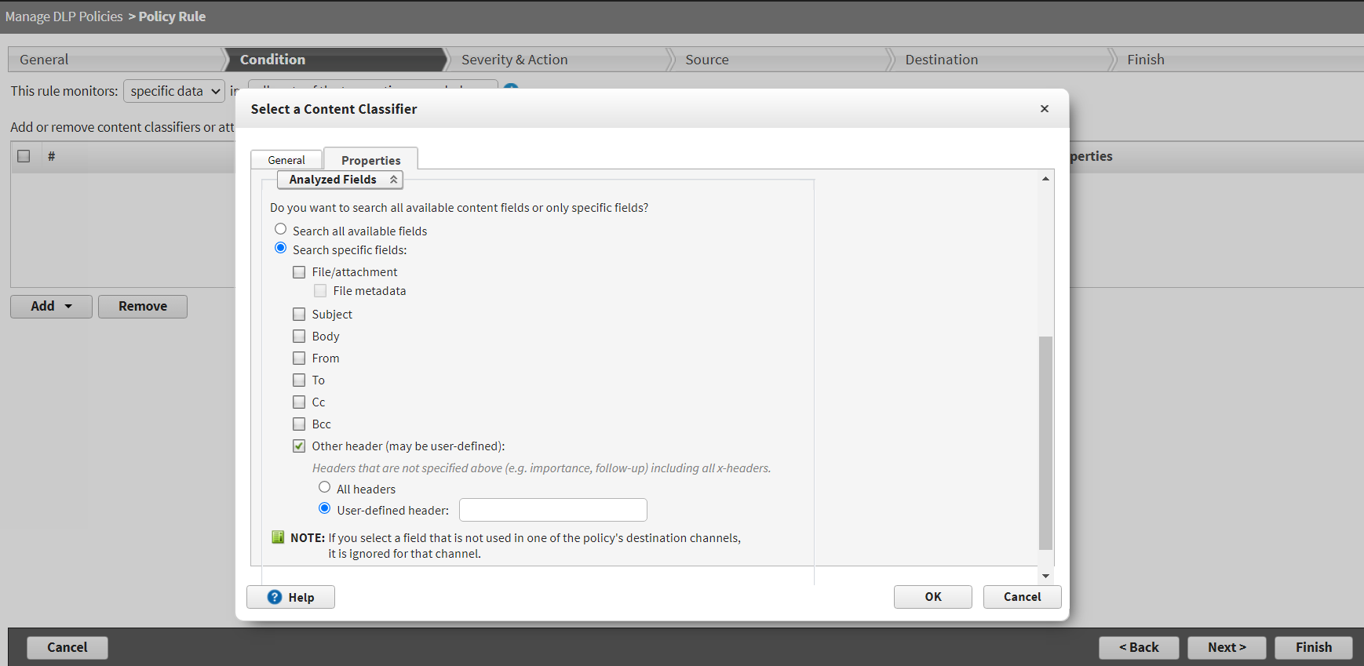
- Click ‘Next’ to get to the ‘Security & Action’ tab
  - Set Email to Permit and all other fields to Block
- Next

